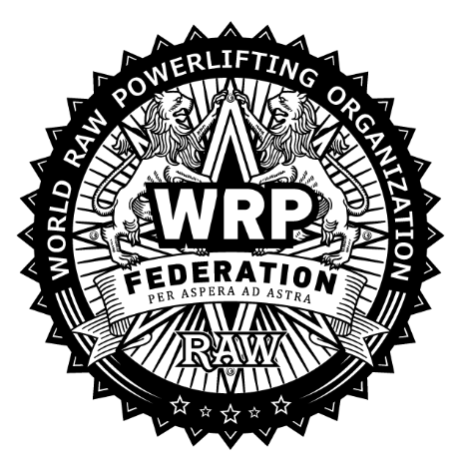

«Agreed»
President of WRPF/WEPF Country
_______________ Ivan Ivanov

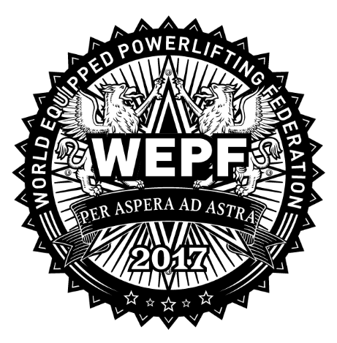

Competition Rules

World Cup Stage «World Cup Series 2027» in powerlifting, push pull, bench press, folk bench press, feet up bench press, russian bench press, deadlift, powersport, strict curl, loglift and hip thrust according to WRPF/WEPF

1. Date and venue of the championship.

Date: June 12-13, 2027.

Venue: Russia, St. Petersburg, Natalia Grudinina Street, 2, building 1, St. Petersburg GBU "Center for Physical Culture, Sports and Health of Kalininsky district" https://yandex.ru/maps/-/CPBq7BZL

Schedule of weighing and lifts will be made based on preliminary applications and will be available from June 1, 2027 on the official English website of the federation: https://wrpf.pro/en/reglament/

2. Divisions.

Championship will be held according to the WRPF/WEPF Technical Rules. Read them in English on our website: https://wrpf.pro/en/pravila/.

Divisions:
- Powerlifting (full power): RAW and with knee wraps (WRPF)
- Powerlifting (full power): Single ply and Multi ply (WEPF)
- Push Pull (bench press & deadlift): RAW (WRPF)
- Push Pull (bench press & deadlift): Equipment (WEPF)
- Squat: RAW and with knee wraps (WRPF), Single ply and Multi ply (WEPF)
- Bench Press: RAW (WRPF)
- Bench Press: Single ply and Multi ply, Soft Equipment «Standard» and «Ultra» (WEPF)
- Bench Press Handicapped: RAW (WRPF)
- Biatlon Bench Press: RAW (WRPF)
- “Folk” Bench Press (bench press to many reps): RAW (WRPF)
- Military Bench Press: RAW (WRPF)
- Russian Bench Press: RAW (WRPF)
- Powersport: RAW (WRPF)
- Army barbell bench press: RAW (WRPF)
- Strict biceps curl: RAW (WRPF)
- Extreme Strict biceps curl: RAW (WRPF)
- Classic biceps curl: RAW (WRPF)
- Biceps curl triple event: RAW (WRPF)
- Biceps curl double event: RAW (WRPF)
- Deadlift: RAW (WRPF)
- Biatlon Deadlift: RAW (WRPF)
- Deadlift: Equipment (WEPF)
- Loglift: RAW (WRPF)
- Hip Thrust: RAW (WRPF)

It is allowed to duplicate the successful attempt from powerlifting to push pull and single lifts. It is allowed to duplicate the successful attempt of division with doping test to division without doping test.

Only certificated referees by WRPF/WEPF are allowed to operate.

3. Applications forms and payments.

Preliminary applications are NECESSARY!!!

The application deadline is May 30, 2027 (inc.) via online registration form on official website of event: https://wrpf.pro/zayavka-na-sorevnovanie/ and https://eu-champ.ru/

Entry Fee:

The fee is paid according to the exchange rate of the Central Bank on the day of payment

Single lift – 75 USD
Double lifts – 140 USD
Three lifts or more – plus 65 USD

Discount for athletes with physical specialties with 3rd disability:
- 50% in one nomination

Free entry fee (in one nomination) for:
- athletes over 65 years old for Men, 60 for Women and under 13 for children.
- sportsmen with physical specialties with 1st or 2nd disability

If an athlete didn't apply until May 30, 2027 (incl), then he would have to pay fines - 25 USD.

WRPF/WAF/WSF membership:

All competitors must be current members of the WRPF/WAF/WSF sport federation at the moment a weighing procedure. The annual membership fee Federation WRPF/WAF/WSF – 15 USD.
Contribution valid for one year from the date of payment and recorded in the database WRPF/WAF/WSF federation athletes.

The athletes pay the entrance fee at the time of the weigh-in.

You can use RUR, USD and EUR. But only cash.

4. Personal rewarding.

Athletes, who take first three places in age and weight class, get the exclusive medals and diplomas.
Absolute rewarding (Best Lifters) occurs in open age class (24-39), teenagers (14-19), juniors (20-23) and masters (over 40) and is calculated by Wilks formula if there are 8 (eight) or more participants in any age class for men and 6 (six) or more participants in age class for women.

Winners and awardees of absolute category get exclusive diplomas, medals or cups, valuable or material prizes if any sponsor help is occurred.

The winners of the absolute primacy (the best lifters) are entitled to a free performance in this profile nomination at the World Cup Series Russia 2028. The second and third place athletes receive a 50% discount for performance in one profile nomination. To confirm it will be necessary to bring a diploma at the registration and weighing.

All awardees or their representatives have to be on awarding ceremony. In other way giving the prizes is not guaranteed.

5. Participants.

Sportsmen, from any region of the world, older than 14 years old are allowed to take part in competitions. Participants under 14 years are allowed before the competition after personal consideration of the athlete's candidature by the organizers of the competition.

All athletes perform at their own risk, realizing that they may get seriously injured. The organizers are not responsible for the health of the athletes, as well as the risks associated with injuries.

Equipment and uniforms of athletes must comply with the rules of the WRPF/WEPF federations. Athletes who do not perform the requirements on equipment and uniforms are not allowed to the platform.

6. Team organization, application rule and rewarding.

To make the team application the captains have to send a general application form before May 30, 2027 to e-mail name@mail.com. The form of the team application and as well as a sample of command counting of points will be posted on the website: http://wrpf.pro/en/dokumenty/ in the "Documents" section.

It is impossible to change anything after the May 30, 2027.

Number of participants is not limited but not less than 9 (nine), assessment of 27 (twenty-seven) best results. Each team must indicate an official represent of team.

To the points received by the athlete for the place she/he taken, additional points are added for the Classification Standards performed as part of the performance at this tournament.

Regardless of whether an athlete performs in the individual competition or for the team, for each separately, athletes must be submitted online application on the e-mail: name@mail.com. In the "Command" column indicates the name of a command or written "Personally."

Teams who becomes winner will gets cups, diplomas, and any valuable or material prizes if any sponsor help is occurred.

7. Registration of National, European, Asian and world Records.

By the results of this Championship National, European, Asian and world records of WRPF/WEPF federation will be fix.

To get the records certificate special online form on official website needs to be send: https://wrpf.pro/en/zayavka-na-sertifikat/.

Athletes must know WRPF/WEPF records before competition: https://wrpf.pro/en/rekordy/.

8. Contact detail.

Organizers:
- President of WRPF/WEPF Country –
- Vice President of WRPF/WEPF Country –
The Head referee: Full name / WRPF/WAF international referee category (city)
The Head Secretary: Full name / WRPF/WAF international referee category (city)

Official website:
Official Instagram page:

9. The contract for participation in the competition.

Passing weighing procedure and registration, each athlete is required to sign the reverse side of the registration card. The fact of signing this card is the conclusion of an Agreement on the participation in the competition between the athlete and the organizers. By signing the card, the athlete agrees with the clauses of this competition rule, as well as with all the points of technical regulations WRPF/WEPF Federation and all of its decisions taken before the start of the competition and published on the official website.

Also, the athlete expressly agrees to the following conditions:

Taking part in the competition, the athlete recognizes that it will require a maximum of physical and psychological stress, which entails a risk of injury or mutilation. Athlete assumes all risks associated with it, and bears full responsibility for any injury and mutilation, about which he known or not, that he can get.

The athlete is realizing that he is responsible for the control of his health before taking part in the competition, thus confirming conducting regular medical check-up, and the absence of medical contraindications for participation in competitions, respectively, his full physical fitness and voluntarily insured his life and health on the period of participation in competition.

Taking part in the competition, the athlete knowingly waives any claims in the event of injury or mutilation in this tournament, against WRPF/WEPF Federation, the tournament organizers, the owner of the premises, directors, officers, employees, assistants on the platform and all operating personnel of competition.

Athlete voluntarily pays for all charitable contributions intended to repay the costs of the tournament, the production of awards merchandise and other expenses related to the sporting events.

Athlete acquainted with this competition rule and fully understand its contents. Athlete voluntarily agrees to accept all of the above paragraph of this provision these conditions and thus confirms this by signing a registration card in the presence of the Secretariat on registration and weighing procedure.

This provision is an official call on the competition

